1. Textbook Questions
2. Random Walk
   1. The daily changes in the closing price of HIS

-0.0289,-0.0211,-0.0179,-0.0175,-0.0168,-0.0165,-0.0160,-0.0155,-0.0151,-0.0150,-0.0147,-0.0142,-0.0128,-0.0125,-0.0119,-0.0105,-0.0100,-0.0097,-0.0091,-0.0091,-0.0088,-0.0080,-0.0080,-0.0079,-0.0071,-0.0069,-0.0067,-0.0066,-0.0062,-0.0060,-0.0060,-0.0059,-0.0058,-0.0054,-0.0052,-0.0048,-0.0043,-0.0042,-0.0041,-0.0037,-0.0036,-0.0035,-0.0034,-0.0032,-0.0030,-0.0030,-0.0029,-0.0028,-0.0027,-0.0026,-0.0025,-0.0024,-0.0024,-0.0023,-0.0019,-0.0018,-0.0013,-0.0013,-0.0009,-0.0008,-0.0008,-0.0008,-0.0008,-0.0007,-0.0007,-0.0006,-0.0006,-0.0004,-0.0002,-0.0002,-0.0001,0.0001,0.0000,0.0000,0.0000,0.0001,0.0002,0.0004,0.0005,0.0006,0.0010,0.0010,0.0011,0.0011,0.0012,0.0013,0.0015,0.0015,0.0018,0.0018,0.0019,0.0020,0.0021,0.0022,0.0023,0.0024,0.0026,0.0027,0.0027,0.0028,0.0028,0.0031,0.0031,0.0033,0.0034,0.0034,0.0037,0.0037,0.0039,0.0041,0.0042,0.0045,0.0047,0.0049,0.0049,0.0049,0.0051,0.0051,0.0054,0.0055,0.0057,0.0057,0.0059,0.0060,0.0062,0.0062,0.0064,0.0066,0.0067,0.0070,0.0071,0.0072,0.0072,0.0073,0.0078,0.0080,0.0081,0.0082,0.0086,0.0087,0.0088,0.0091,0.0098,0.0100,0.0103,0.0106,0.0107,0.0109,0.0120,0.0125,0.0129,0.0134,0.0145,0.0145,0.0147,0.0151,0.0155,0.0169,0.0174,0.0178,0.0182,0.0191

<https://github.com/Wood-Li/CUHK-Statiscal-Analysis/blob/master/HSI%20data.xlsx>

* 1. The data from 2a is not normally distributed.
     1. Descriptive statistics

Mean=0.0005

Median=0.0010

Mean does not equal to median so the data is not normally distributed.

* + 1. Application of Empirical rule

The Empirical rule says 68% of data are between -0.0078 and 0.0089, but in fact there are 72% of data between -0.0078 and 0.0089.

* 1. The characteristics of the data
     1. Histogram

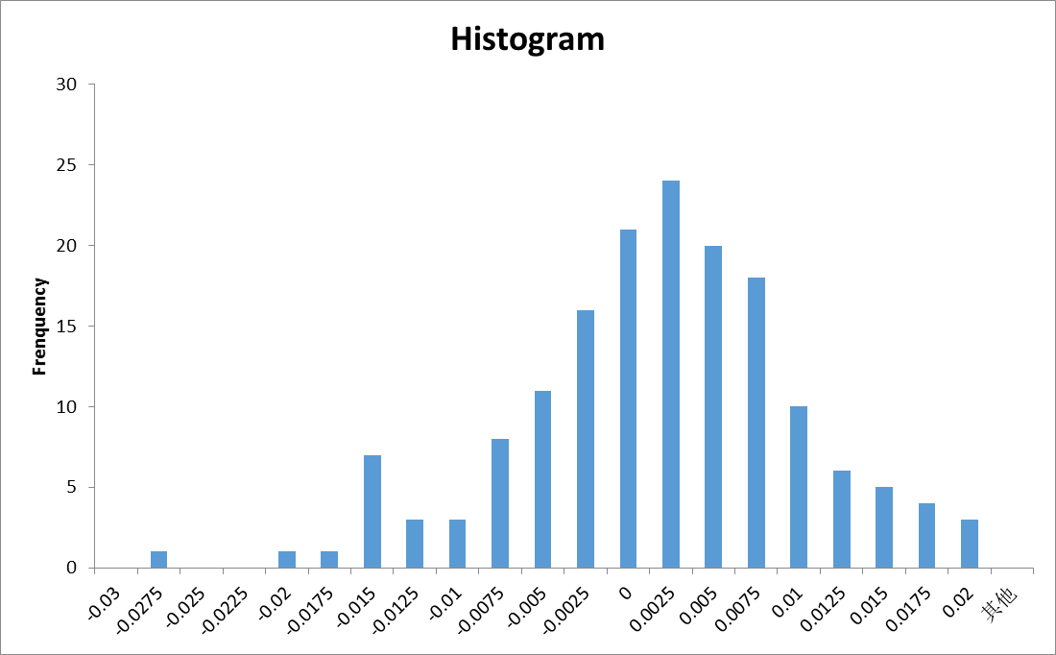

* + 1. The normal probability plot

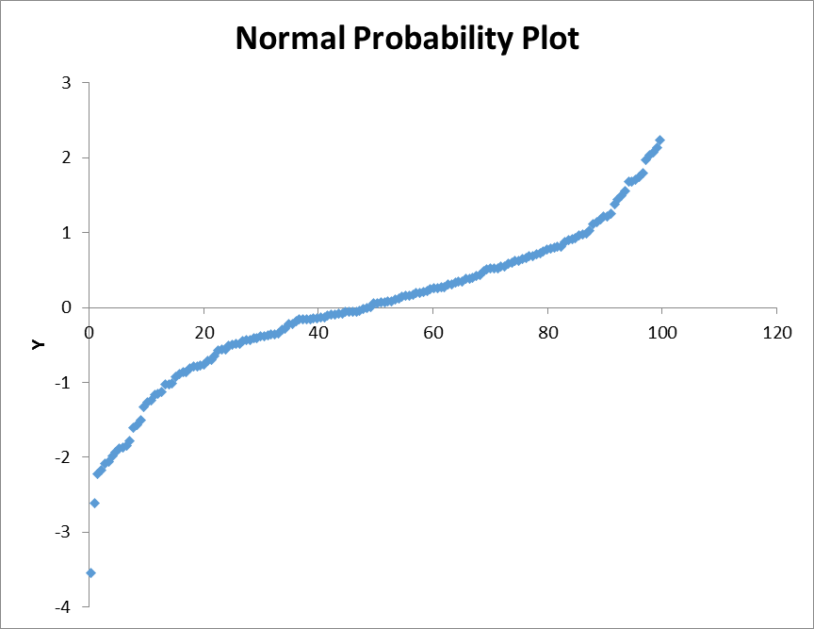

The data is not symmetrical.

* + 1. Descriptive statistics

Mean=0.0005

Median=0.0010

Standard deviation=0.0084

* 1. Choose the daily changes in closing price 0883.HK in the period of 3th Jan’ 2014 to 31th Aug’ 2014 as our data.
     1. The data

-0.0630,-0.0541,-0.0536,-0.0348,-0.0289,-0.0265,-0.0256,-0.0231,-0.0231,-0.0222,-0.0221,-0.0213,-0.0206,-0.0197,-0.0175,-0.0174,-0.0168,-0.0156,-0.0156,-0.0145,-0.0132,-0.0130,-0.0126,-0.0126,-0.0125,-0.0124,-0.0119,-0.0114,-0.0113,-0.0108,-0.0095,-0.0094,-0.0093,-0.0090,-0.0088,-0.0086,-0.0086,-0.0080,-0.0072,-0.0072,-0.0068,-0.0063,-0.0063,-0.0062,-0.0059,-0.0059,-0.0058,-0.0057,-0.0052,-0.0049,-0.0045,-0.0044,-0.0044,-0.0043,-0.0043,-0.0043,-0.0043,-0.0043,-0.0042,-0.0040,-0.0031,-0.0031,-0.0030,-0.0029,-0.0028,-0.0017,-0.0016,-0.0015,-0.0015,-0.0015,-0.0015,-0.0015,-0.0014,-0.0013,0.0000,0.0000,0.0000,0.0000,0.0000,0.0000,0.0000,0.0000,0.0000,0.0000,0.0000,0.0013,0.0014,0.0015,0.0015,0.0016,0.0016,0.0016,0.0017,0.0017,0.0029,0.0029,0.0029,0.0029,0.0032,0.0035,0.0035,0.0035,0.0041,0.0043,0.0043,0.0047,0.0049,0.0057,0.0058,0.0059,0.0063,0.0063,0.0064,0.0065,0.0067,0.0069,0.0069,0.0072,0.0072,0.0073,0.0074,0.0075,0.0079,0.0089,0.0091,0.0093,0.0095,0.0101,0.0102,0.0103,0.0105,0.0108,0.0112,0.0115,0.0115,0.0116,0.0117,0.0117,0.0119,0.0125,0.0127,0.0136,0.0138,0.0139,0.0142,0.0146,0.0149,0.0153,0.0163,0.0166,0.0169,0.0172,0.0175,0.0191,0.0193,0.0221,0.0221,0.0232,0.0234,0.0235,0.0241,0.0252,0.0256,0.0258,0.0288,0.0291,0.0295,0.0367,0.0395,0.0479

<https://github.com/Wood-Li/CUHK-Statiscal-Analysis/blob/master/0883.HK%20Data.xlsx>

* + 1. The data is not normally distributed.
       1. Descriptive statistics

Mean=0.0008

Median=0.0007

Mean does not equal to median so the data is not normally distributed.

* + - 1. Application of Empirical rule

The Empirical rule says 68% of data are between -0.0146 and 0.0162, but in fact there are 75.7% of data between -0.0146 and 0.0162.

* + 1. The characteristics of the data
       1. Histogram

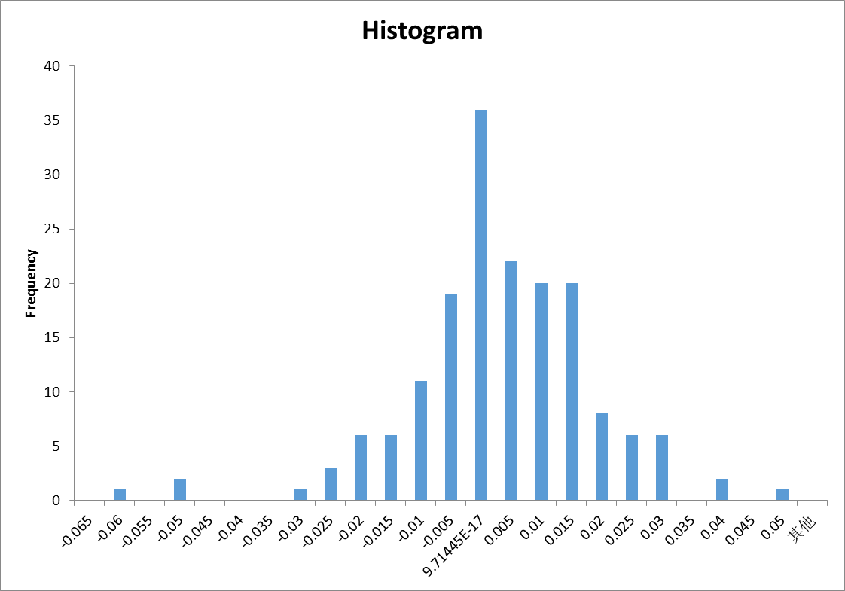

* + - 1. The normal probability plot

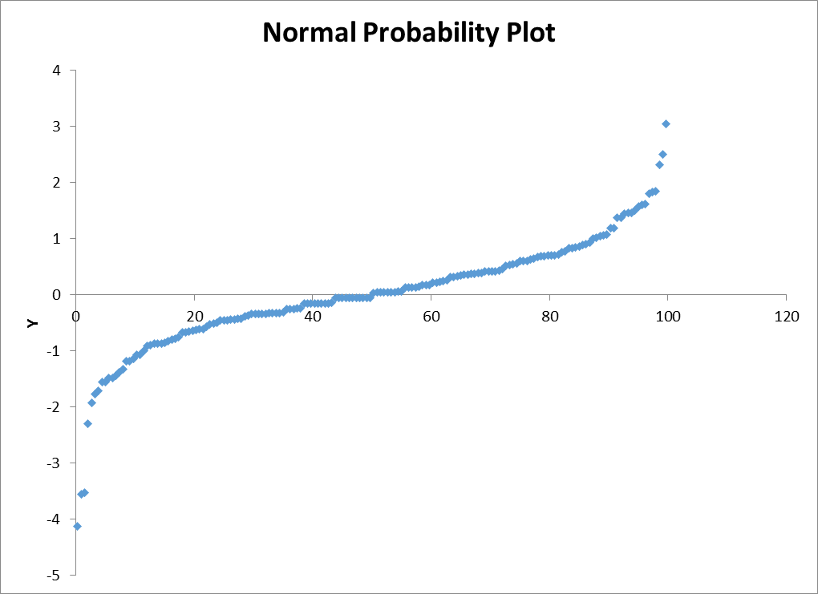

The data is not symmetrical.

* + - 1. Descriptive statistics

Mean=0.0008

Median=0.0007

Standard deviation=0.0154